

**YOGA CENTER**

**Software Design Document**

– HCM, May 2023 –

**Table of Contents**

I. Overview 4

1. Code Packages/Namespaces 4

2. Database Schema 4

II. Code Designs 6

1. Guest/Login 6

a. Class Diagram 6

b. Class Specifications 6

c. Sequence Diagram(s) 7

2. Guest/Register 8

a. Class Diagram 8

b. Class Specifications 8

c. Sequence Diagram(s) 9

3. Customer/Payment 10

a. Class Diagram 10

b. Class Specifications 11

c. Sequence Diagram(s) 11

4. Staff/Manage Semester 12

a. Class Diagram 12

b. Class Specifications 13

c. Sequence Diagram(s) 13

5. Staff/Manage Course 15

a. Class Diagram 15

b. Class Specifications 16

c. Sequence Diagram(s) 16

6. Staff/Manage Slot 19

a. Class Diagram 20

b. Class Specifications 21

c. Sequence Diagram(s) 21

7. Staff/Manage Class 23

a. Class Diagram 23

b. Class Specifications 24

c. Sequence Diagram(s) 24

8. Staff/Manage Package 28

a. Class Diagram 28

b. Class Specifications 29

c. Sequence Diagram(s) 30

9. Staff/Manage News 32

a. Class Diagram 32

b. Class Specifications 33

c. Sequence Diagram(s) 33

10. Staff/Manage Member 35

a. Class Diagram 35

b. Class Specifications 36

c. Sequence Diagram(s) 36

11. Admin/Manage Account 38

a. Class Diagram 38

b. Class Specifications 39

c. Sequence Diagram(s) 39

III. Database Tables 41

1. Account 41

2. Role 41

3. Schedule 41

4. Courses 41

5. Booking 42

6. Classes 42

7. Semester 42

8. Payment 42

9. PaymentMethod 43

10. Premium 43

11. News 43

# I. Overview

## 1. Code Packages/Namespaces

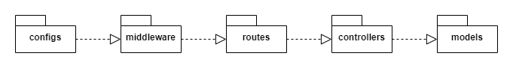

***Package descriptions & package class naming conventions***

|  |  |  |
| --- | --- | --- |
| **No** | **Package** | **Description** |
| 01 | configs | * The directory contains the application's configuration files. * lowercase (ex: config.js) |
| 02 | middleware | * Directory containing middleware files, used to perform processing tasks before the request reaches the destination. * camelCase (ex: userMiddleware.js) |
| 03 | routes | * The directory contains the route files to handle requests from the client and call the functions in the corresponding controller. * snake-case (user-routes.js) |
| 04 | controllers | * Directory containing file controllers to control application logic. * camelCase (ex: userController.js) |
| 05 | models | * Directory containing model files that define the database structure and methods for interacting with the database. * camelCase (ex: userModel.js) |

## 2. Database Schema

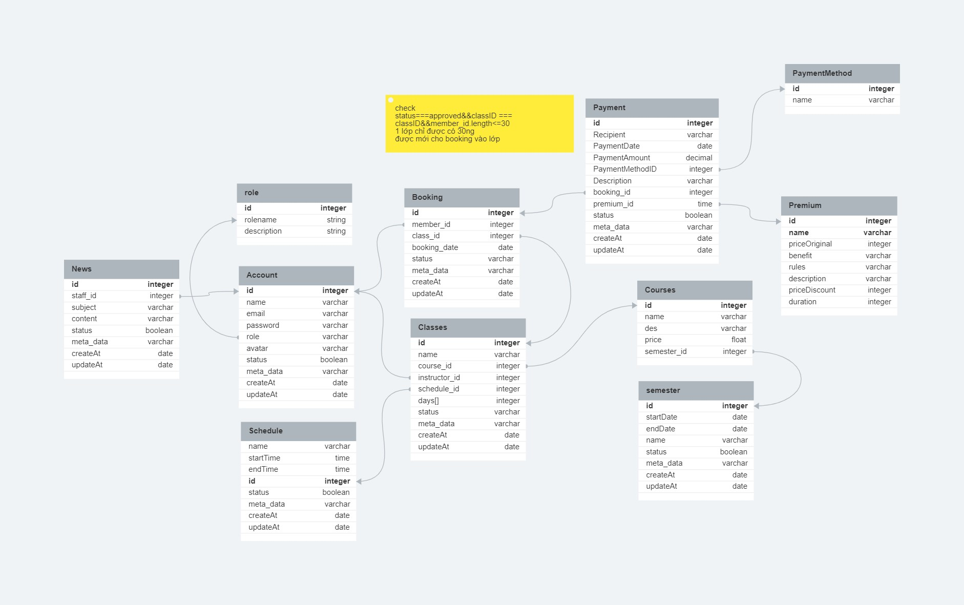

***Table descriptions & package class naming conventions are as below***

|  |  |  |
| --- | --- | --- |
| **No** | **Table** | **Description** |
|  | Account | * Contains information of all accounts logged into the system. * Primary key: account_id * Foreign key: role_id |
|  | Role | * Contain information of all role in the system. * Primary key: id |
|  | Booking | * Contains all information of customer booking * Primary key: booking_id * Foreign keys: account_id, class_id |
|  | Classes | * Contains information of all classes in charge of the instructor * Primary key: class_id * Foreign keys: courses_id schedule_id, account_id |
|  | Schedule | * Contains information of customer, staff schedule * Primary key: id |
|  | Courses | * Contains all information courses available * Primary key: courses_id * Foreign keys: semester_id |
|  | Semester | * Contains information of course in each semester * Primary key: semester_id |
|  | Payment | * Contains information of payment in the system. * Primary key: id * Foreign keys: bookig_id, method_id, premium_id |
|  | PaymentMethod | * Contains information of method payment in the system. * Primary key: id |
|  | Premium | * Contains information of premium package in the system. * Primary key: id |
|  | News | * Contains information of news in the system. * Primary key: id |

# II. Code Designs

## 1. Guest/Login

### a. Class Diagram

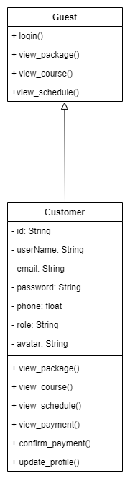

### b. Class Specifications

|  |  |  |
| --- | --- | --- |
| **No** | **Method** | **Description** |
| 1. 01 | view_package() | Using to view the package |
|  | view_course() | Using to view the course |
|  | view_schedule() | Using to view the schedule |
|  | view_payment() | Using to view the payment |
|  | confirm_payment() | Using to confirm payment |
|  | update_profile() | Using to update profile |
|  | login() | Using to login into the system |

### c. Sequence Diagram(s)

#### 

## 2. Guest/Register

### a. Class Diagram

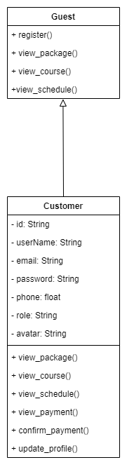

### b. Class Specifications

|  |  |  |
| --- | --- | --- |
| **No** | **Method** | **Description** |
| 1. 01 | view_package() | Using to view the package |
|  | view_course() | Using to view the course |
|  | view_schedule() | Using to view the schedule |
|  | view_payment() | Using to view the payment |
|  | confirm_payment() | Using to confirm payment |
|  | update_profile() | Using to update profile |
|  | register() | Using to login into the system |

### c. Sequence Diagram(s)

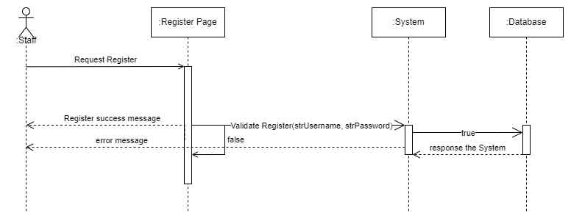

## 3. Customer/Payment

### a. Class Diagram

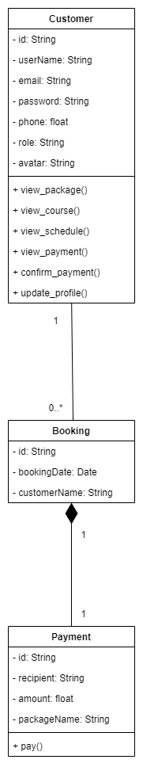

### b. Class Specifications

|  |  |  |
| --- | --- | --- |
| **No** | **Method** | **Description** |
| 1. 01 | view_package() | Using to view the package |
|  | view_course() | Using to view the course |
|  | view_schedule() | Using to view the schedule |
|  | view_payment() | Using to view the payment |
|  | confirm_payment() | Using to confirm_payment |
|  | update_profile() | Using to update profile |
|  | pay() | Using to pay the bill |

### c. Sequence Diagram(s)

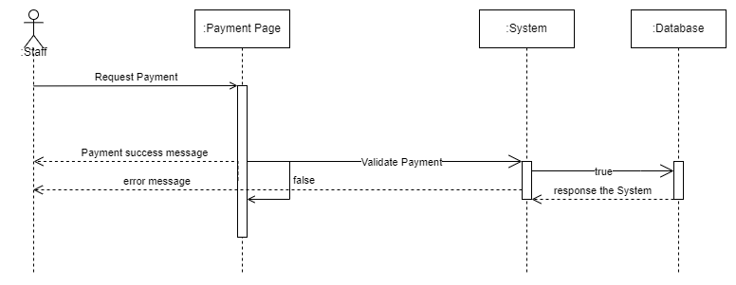

## 4. Staff/Manage Semester

### a. Class Diagram

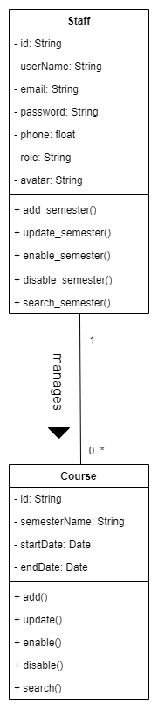

### b. Class Specifications

|  |  |  |
| --- | --- | --- |
| **No** | **Method** | **Description** |
| 1. 01 | add_semester() | Using to add the new semester |
|  | update_semester() | Using to update the semester |
|  | enable_semester() | Using to enable the semester |
|  | disable_semester() | Using to disable the semester |
|  | search_semester() | Using to search the semester |

### c. Sequence Diagram(s)

#### c.1 Add Semester

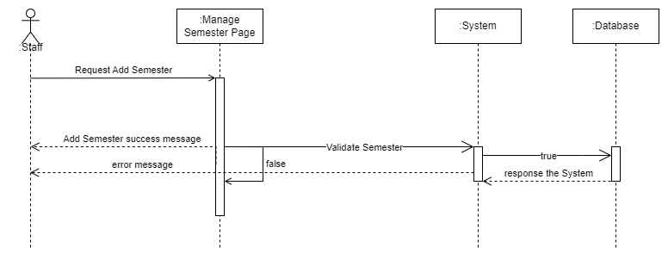

#### c.2 Update Semester

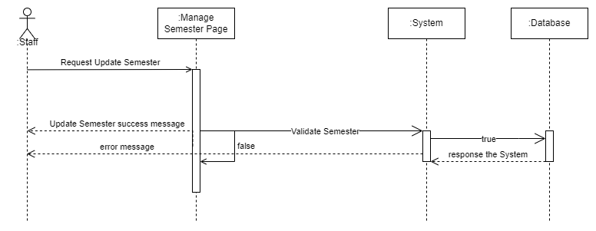

#### c.3 Enable Semester

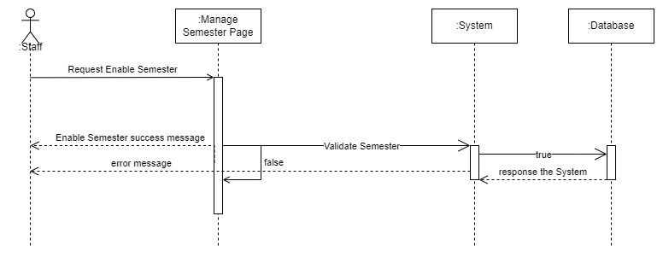

#### c.4 Disable Semester

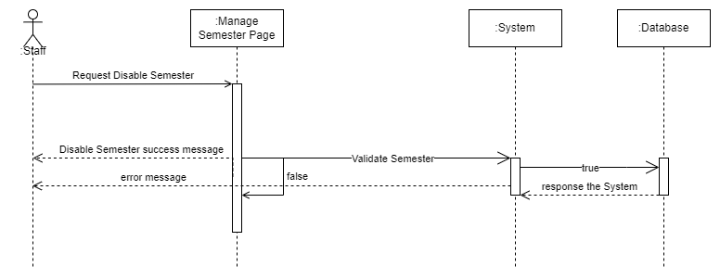

#### c.5 Search Semester

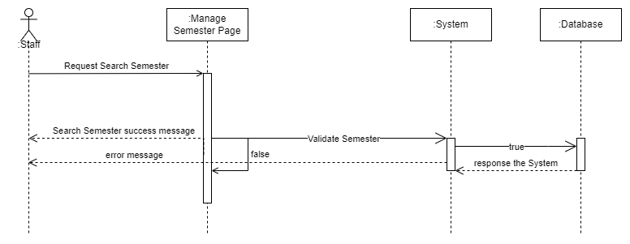

## 5. Staff/Manage Course

### a. Class Diagram

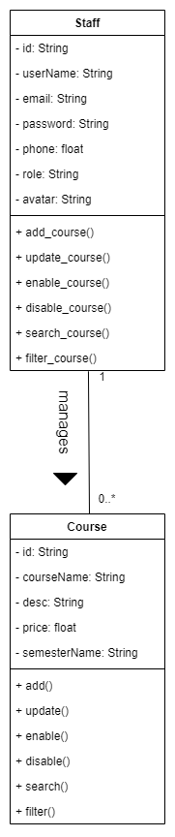

### b. Class Specifications

|  |  |  |
| --- | --- | --- |
| **No** | **Method** | **Description** |
| 1. 01 | add_course() | Using to add the new course |
|  | update_course() | Using to update the course |
|  | enable_course() | Using to enable the course |
|  | disable_couse() | Using to disable the course |
|  | search_course() | Using to search the course |
|  | filter_course() | Using to filter the course |

### c. Sequence Diagram(s)

#### c.1 Add Course

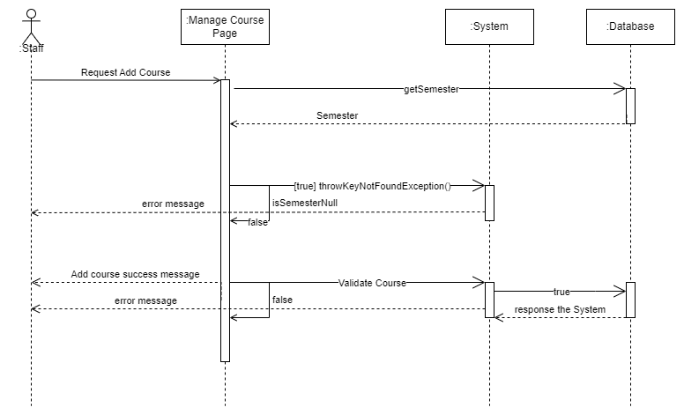

#### c.2 Update Course

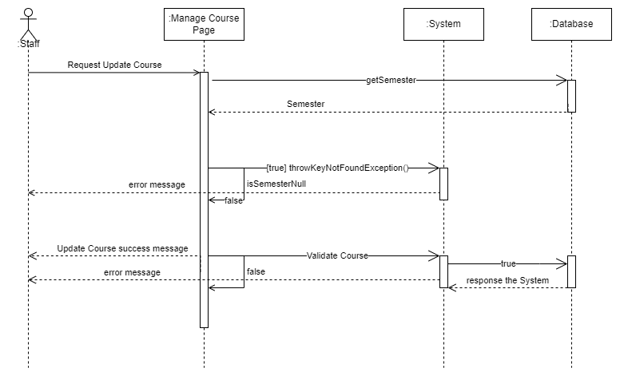

#### c.3 Enable Course

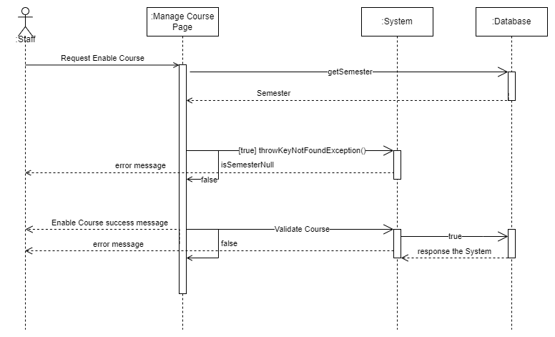

#### c.4 Disable Course

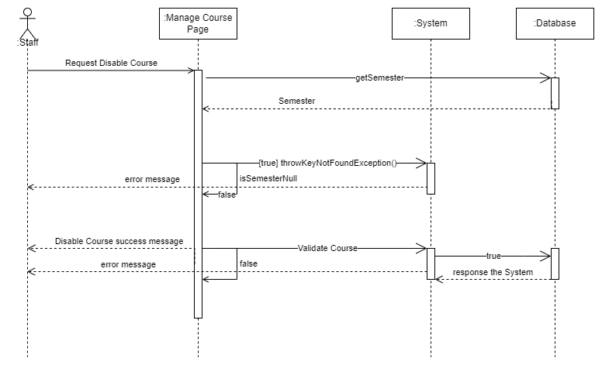

#### c.5 Search Course

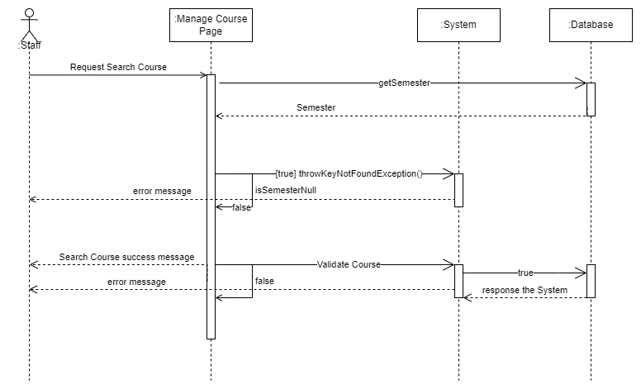

#### c.6 Filter Course

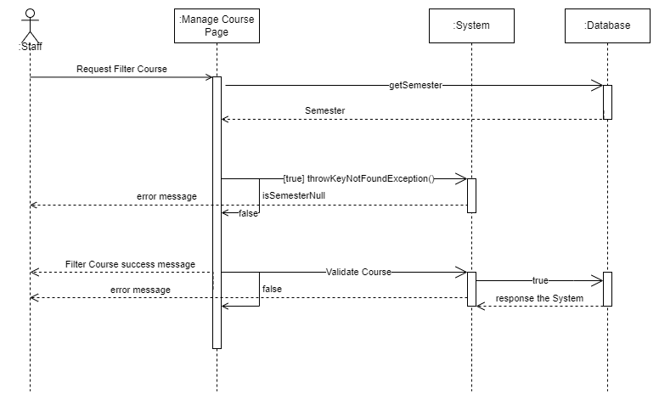

6. Staff/Manage Slot

### a. Class Diagram

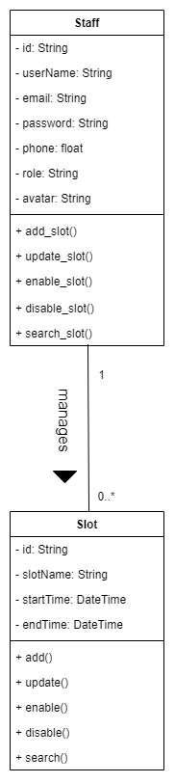

### b. Class Specifications

|  |  |  |
| --- | --- | --- |
| **No** | **Method** | **Description** |
| 1. 01 | add_slot() | Using to add the new slot |
|  | update_slot() | Using to update the slot |
|  | enable_slot() | Using to enable the slot |
|  | disable_slot() | Using to disable the slot |
|  | search_slot() | Using to search the slot |

### c. Sequence Diagram(s)

#### c.1 Add Slot

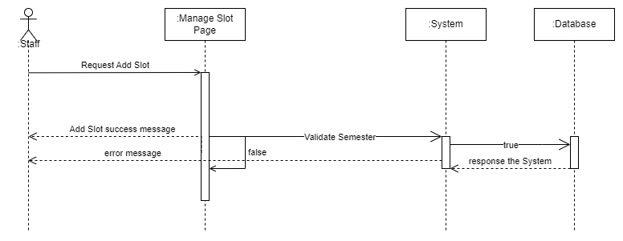

#### c.2 Update Slot

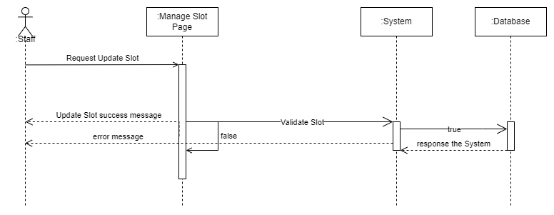

#### c.3 Enable Slot

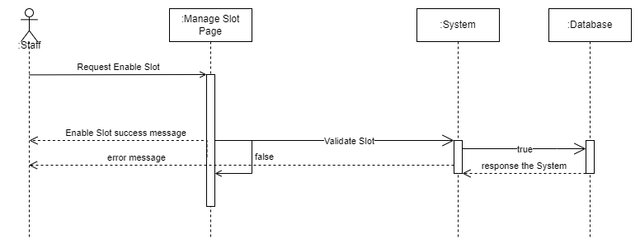

#### c.4 Disable Slot

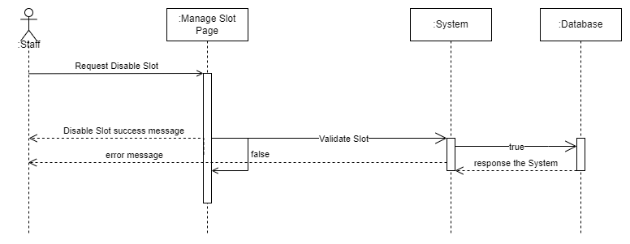

#### c.5 Search Slot

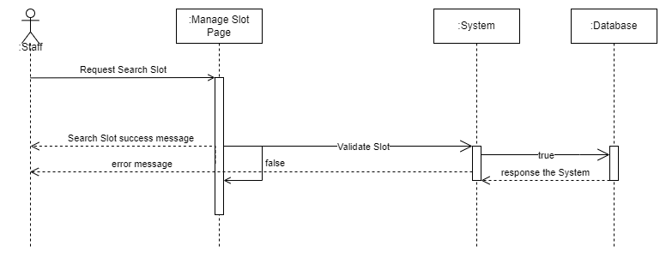

## 7. Staff/Manage Class

### a. Class Diagram

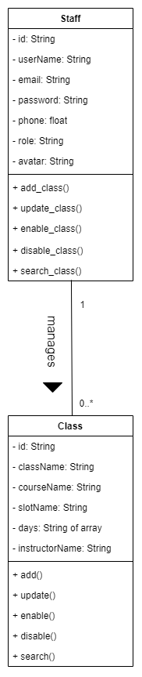

### b. Class Specifications

|  |  |  |
| --- | --- | --- |
| **No** | **Method** | **Description** |
| 1. 01 | add_class() | Using to add the new class |
|  | update_class() | Using to update the class |
|  | enable_class() | Using to enable the class |
|  | disable_class() | Using to disable the class |
|  | search_class() | Using to search the class |

### c. Sequence Diagram(s)

#### c.1 Add Class

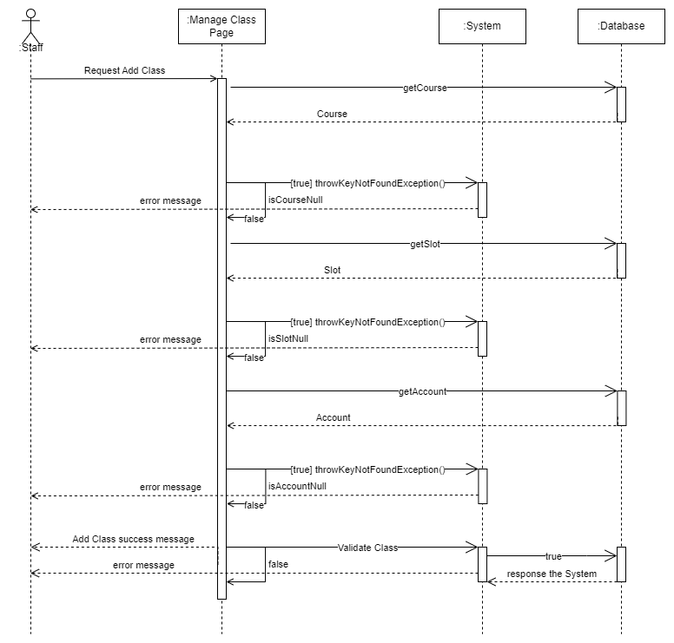

#### c.2 Update Class

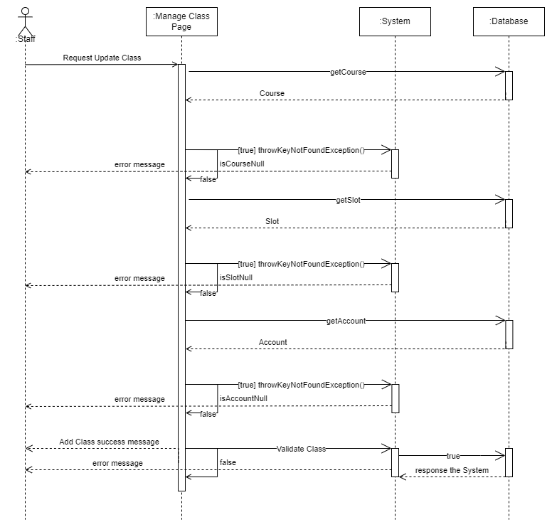

#### c.3 Enable Class

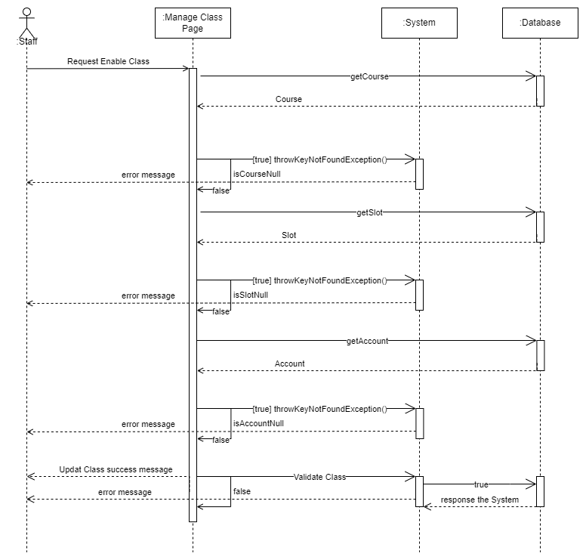

#### c.4 Disable Class

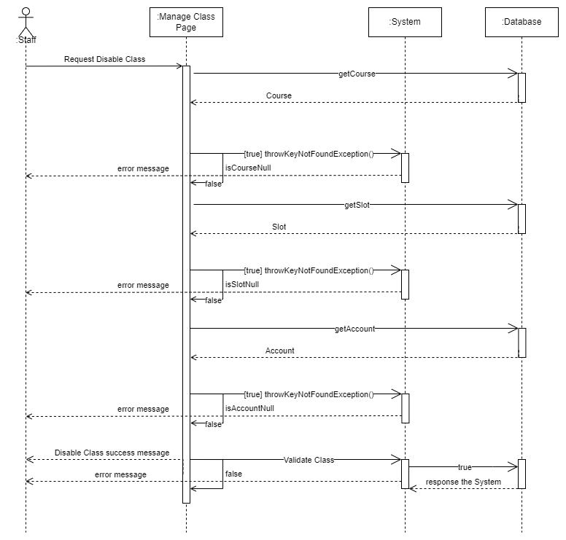

#### c.5 Search Class

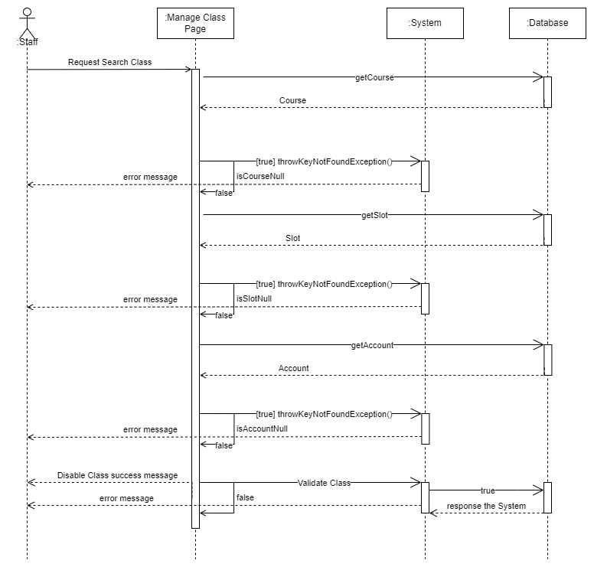

## 8. Staff/Manage Package

### a. Class Diagram

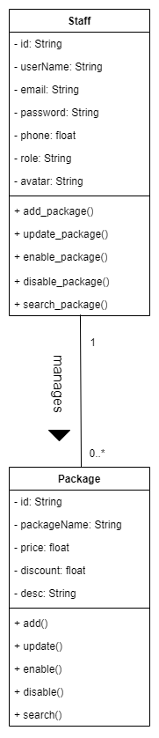

### b. Class Specifications

|  |  |  |
| --- | --- | --- |
| **No** | **Method** | **Description** |
| 1. 01 | add_package() | Using to add the new package |
|  | update_package() | Using to update the package |
|  | enable_ package () | Using to enable the package |
|  | disable_ package () | Using to disable the package |
|  | search_ package () | Using to search the package |

### c. Sequence Diagram(s)

#### c.1 Add Package

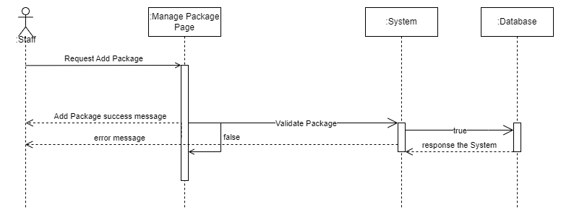

#### c.2 Update Package

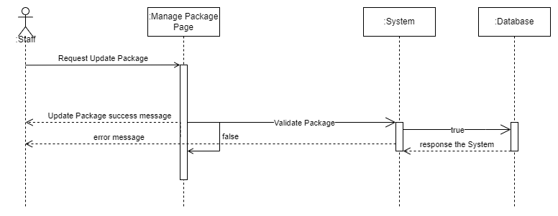

#### c.3 Enable Package

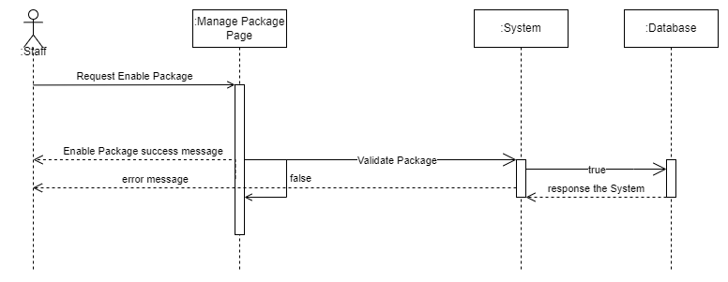

#### c.4 Disable Package

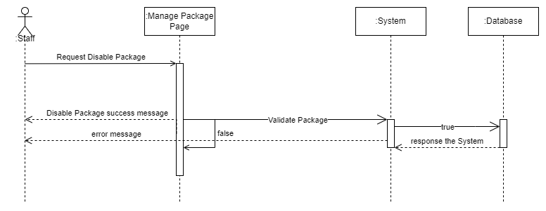

#### c.5 Search Package

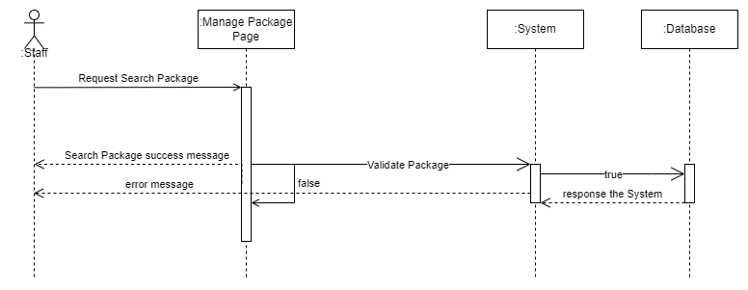

## 9. Staff/Manage News

### a. Class Diagram

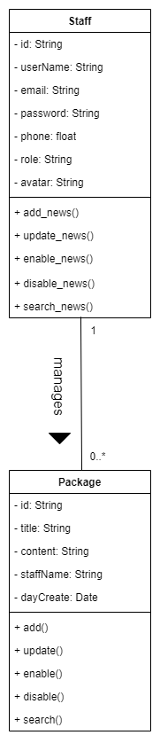

### b. Class Specifications

|  |  |  |
| --- | --- | --- |
| **No** | **Method** | **Description** |
| 1. 01 | add_news() | Using to add the news |
|  | update_ news () | Using to update the news |
|  | enable_ news () | Using to enable the news |
|  | disable_ news () | Using to disable the news |
|  | search_ news () | Using to search the news |

### c. Sequence Diagram(s)

#### c.1 Add News

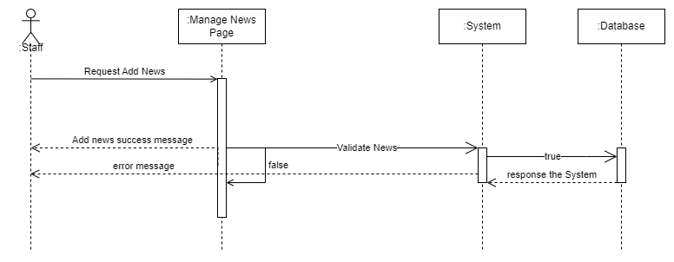

#### c.2 Update News

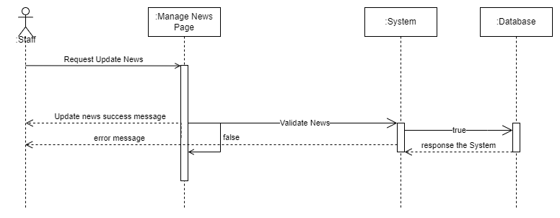

#### c.3 Enable News

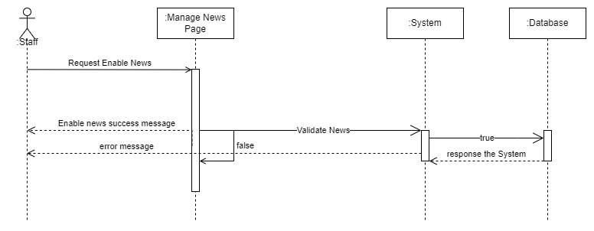

#### c.4 Disable News

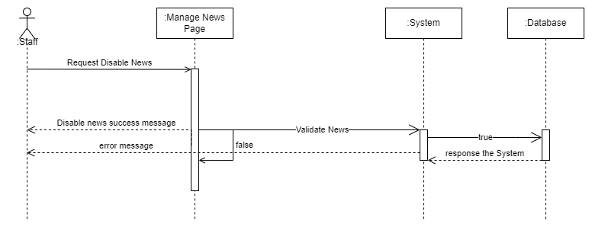

#### c.5 Search News

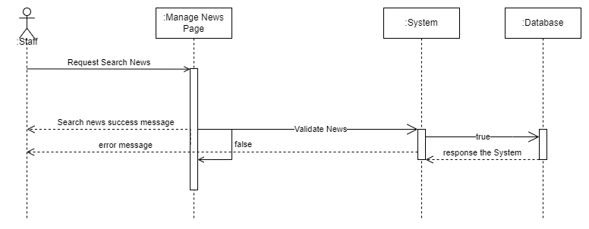

## 10. Staff/Manage Member

### a. Class Diagram

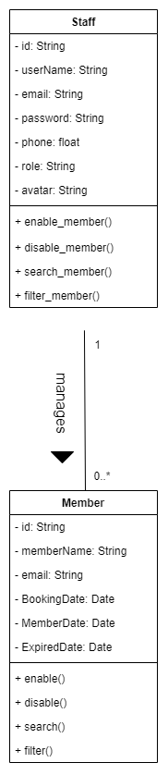

### b. Class Specifications

|  |  |  |
| --- | --- | --- |
| **No** | **Method** | **Description** |
|  | enable_ member() | Using to enable the member |
|  | disable_ member() | Using to disable the member |
|  | search_ member () | Using to search the member |
|  | filter_ member() | Using to filter the member |

### c. Sequence Diagram(s)

#### c.1 Enable Member

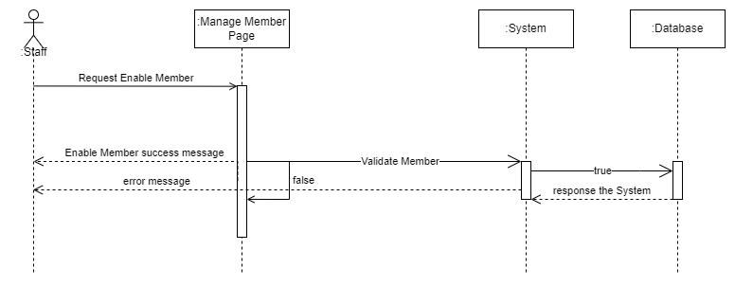

#### c.2 Disable Member

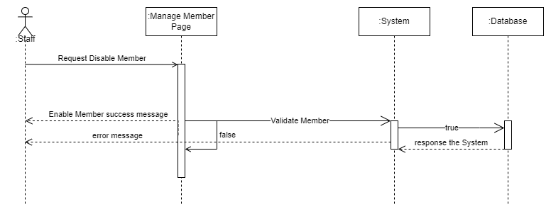

#### c.3 Search Member

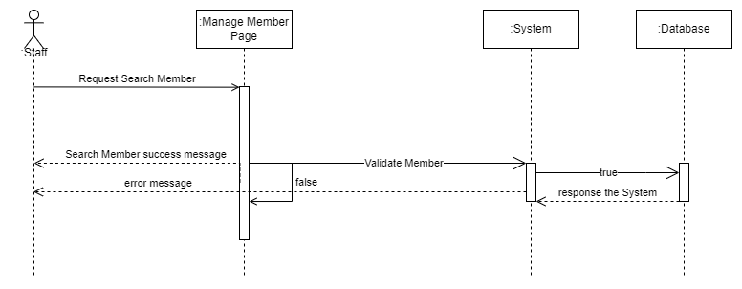

#### c.4 Filter Member

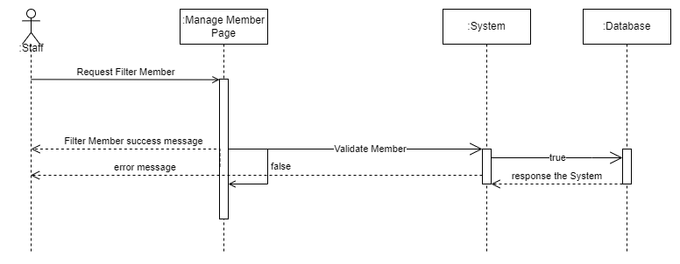

## 11. Admin/Manage Account

### a. Class Diagram

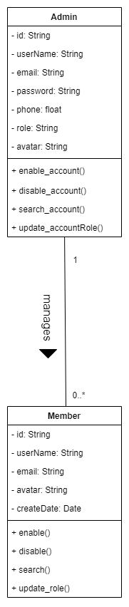

### b. Class Specifications

|  |  |  |
| --- | --- | --- |
| **No** | **Method** | **Description** |
|  | enable_ account() | Using to enable the account |
|  | disable_ account() | Using to disable the account |
|  | search_ account() | Using to search the account |
|  | update_role() | Using to update the account role |

### c. Sequence Diagram(s)

#### c.1 Enable Account

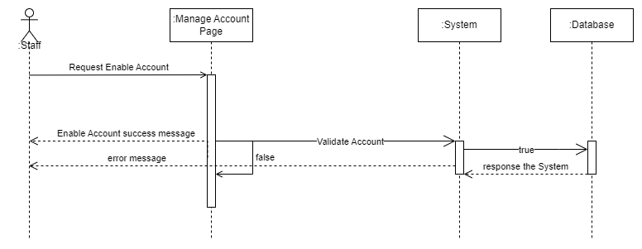

#### c.2 Disable Account

#### c.3 Search Account

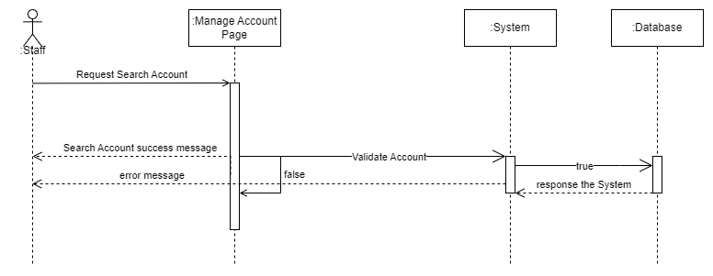

#### c.4 Update role

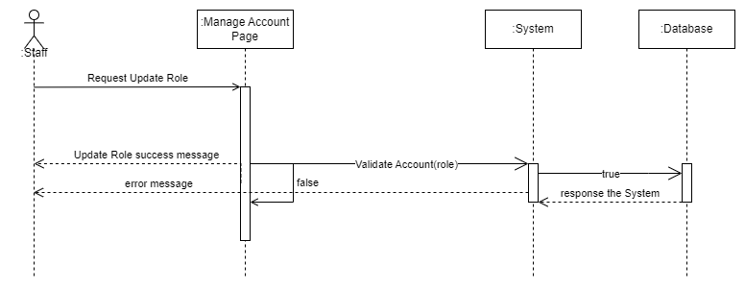

# III. Database Tables

## 1. Account

|  |  |  |  |  |  |  |  |
| --- | --- | --- | --- | --- | --- | --- | --- |
| **#** | **Field name** | **Type** | **Size** | **Unique** | **Not Null** | **PK/FK** | **Notes** |
| 1. 1 | id | Integer | 4 | true | true | PK |  |
| 1. 2 | name | varchar | 0 to 65,535 |  |  |  |  |
|  | Email | varchar | 0 to 65,535 |  |  |  |  |
|  | password | varchar | 0 to 65,535 |  |  |  |  |
|  | role_id | varchar | 0 to 65,535 |  |  | FK | Foreign key: role_id of table Role |
|  | avatar | varchar | 0 to 65,535 |  |  |  |  |
|  | status | Boolean |  |  |  |  |  |

## 2. Role

|  |  |  |  |  |  |  |  |
| --- | --- | --- | --- | --- | --- | --- | --- |
| **#** | **Field name** | **Type** | **Size** | **Unique** | **Not Null** | **PK/FK** | **Notes** |
| 1. 1 | id | Integer | 4 | true | true | PK |  |
| 1. 2 | Rolename | String |  | true |  |  |  |
|  | Email | String |  |  |  |  |  |
|  | status | Boolean |  |  |  |  |  |

## 3. Schedule

|  |  |  |  |  |  |  |  |
| --- | --- | --- | --- | --- | --- | --- | --- |
| **#** | **Field name** | **Type** | **Size** | **Unique** | **Not Null** | **PK/FK** | **Notes** |
| 1. 1 | id | Integer | 4 | true | true | PK |  |
| 1. 2 | startTime | Time | 3 to 5 |  |  |  |  |
|  | endTime | Time | 3 to 5 |  |  |  |  |
|  | status | Boolean |  |  |  |  |  |

## 4. Courses

|  |  |  |  |  |  |  |  |
| --- | --- | --- | --- | --- | --- | --- | --- |
| **#** | **Field name** | **Type** | **Size** | **Unique** | **Not Null** | **PK/FK** | **Notes** |
| 1. 1 | id | Integer | 4 | true | true | PK |  |
| 1. 2 | name | Varchar | 3 to 5 |  |  |  |  |
|  | des | Varchar | 3 to 5 |  |  |  |  |
|  | price | Float | Depends on the value of n |  |  |  |  |
|  | Semester_id | Integer | 4 |  |  | FK | Foreign key: semester_id of table Semester |
|  | status | Boolean |  |  |  |  |  |

## 5. Booking

|  |  |  |  |  |  |  |  |
| --- | --- | --- | --- | --- | --- | --- | --- |
| **#** | **Field name** | **Type** | **Size** | **Unique** | **Not Null** | **PK/FK** | **Notes** |
| 1. 1 | id | Integer | 4 | true | true | PK |  |
| 1. 2 | member_id | Integer | 4 |  |  | FK | Foreign key: member_id of table Account |
|  | Class_id | Integer | 4 |  |  | FK | Foreign key: class_id of table Classes |
|  | Booking_date | Date | 3 |  |  |  |  |
|  | status | Varchar | 0 to 65,535 |  |  |  |  |

## 6. Classes

|  |  |  |  |  |  |  |  |
| --- | --- | --- | --- | --- | --- | --- | --- |
| **#** | **Field name** | **Type** | **Size** | **Unique** | **Not Null** | **PK/FK** | **Notes** |
| 1. 1 | id | Integer | 4 | true | true | PK |  |
| 1. 2 | Course_id | Integer | 4 |  |  | FK | Foreign key: member_id of table Courses |
|  | Instructor_id | Integer | 4 |  |  | FK | Foreign key: class_id of table Account |
|  | Schedule_id | Integer | 4 |  |  | FK | Foreign key: class_id of table Schedule |
|  | Days | Array of Integer | 4 |  |  |  |  |
|  | status | Boolean |  |  |  |  |  |

## 7. Semester

|  |  |  |  |  |  |  |  |
| --- | --- | --- | --- | --- | --- | --- | --- |
| **#** | **Field name** | **Type** | **Size** | **Unique** | **Not Null** | **PK/FK** | **Notes** |
| 1. 1 | id | Integer | 4 | true | true | PK |  |
| 1. 2 | startDate | Date | 3 |  |  |  |  |
|  | endDate | Date | 3 |  |  |  |  |
|  | name | Varchar | 0 to 65,535 |  |  |  |  |
|  | status | Boolean |  |  |  |  |  |

## 8. Payment

|  |  |  |  |  |  |  |  |
| --- | --- | --- | --- | --- | --- | --- | --- |
| **#** | **Field name** | **Type** | **Size** | **Unique** | **Not Null** | **PK/FK** | **Notes** |
| 1. 1 | id | Integer | 4 | true | true | PK |  |
| 1. 2 | PaymentDate | Date | 3 |  |  |  |  |
|  | PaymentAmount | Date | 3 |  |  |  |  |
|  | Recipient | Varchar | 0 to 65,535 |  |  |  |  |
|  | Description | Varchar | 0 to 65,535 |  |  |  |  |
|  | PaymentMethodID | Integer | 4 |  |  | FK | Foreign Key: paymentmethod_id of table PaymentMethod |
|  | booking_id | Integer | 4 |  |  | FK | Foreign Key: booking_id of table Booking |
|  | premium_id | Integer | 4 |  |  | FK | Foreign Key: premium_id of table Premium |
|  | status | Boolean |  |  |  |  |  |

## 9. PaymentMethod

|  |  |  |  |  |  |  |  |
| --- | --- | --- | --- | --- | --- | --- | --- |
| **#** | **Field name** | **Type** | **Size** | **Unique** | **Not Null** | **PK/FK** | **Notes** |
| 1. 1 | id | Integer | 4 | true | true | PK |  |
| 1. 2 | name | Varchar | 0 to 65,535 |  |  |  |  |
|  | status | Boolean |  |  |  |  |  |

## 10. Premium

|  |  |  |  |  |  |  |  |
| --- | --- | --- | --- | --- | --- | --- | --- |
| **#** | **Field name** | **Type** | **Size** | **Unique** | **Not Null** | **PK/FK** | **Notes** |
| 1. 1 | id | Integer | 4 | true | true | PK |  |
| 1. 2 | name | Varchar | 0 to 65,535 |  |  |  |  |
|  | benefit | Varchar | 0 to 65,535 |  |  |  |  |
|  | rules | Varchar | 0 to 65,535 |  |  |  |  |
|  | description | Integer | 4 |  |  |  |  |
|  | priceOriginal | Integer | 4 |  |  |  |  |
|  | priceDiscount | Integer | 4 |  |  |  |  |
|  | duration | Integer | 4 |  |  |  |  |
|  | status | Boolean |  |  |  |  |  |

## 11. News

|  |  |  |  |  |  |  |  |
| --- | --- | --- | --- | --- | --- | --- | --- |
| **#** | **Field name** | **Type** | **Size** | **Unique** | **Not Null** | **PK/FK** | **Notes** |
| 1. 1 | id | Integer | 4 | true | true | PK |  |
| 1. 2 | subject | Varchar | 0 to 65,535 |  |  |  |  |
|  | content | Varchar | 0 to 65,535 |  |  |  |  |
|  | account_id | Integer | 4 |  |  | FK | Foreign key: account_id of table Account |
|  | status | Boolean |  |  |  |  |  |